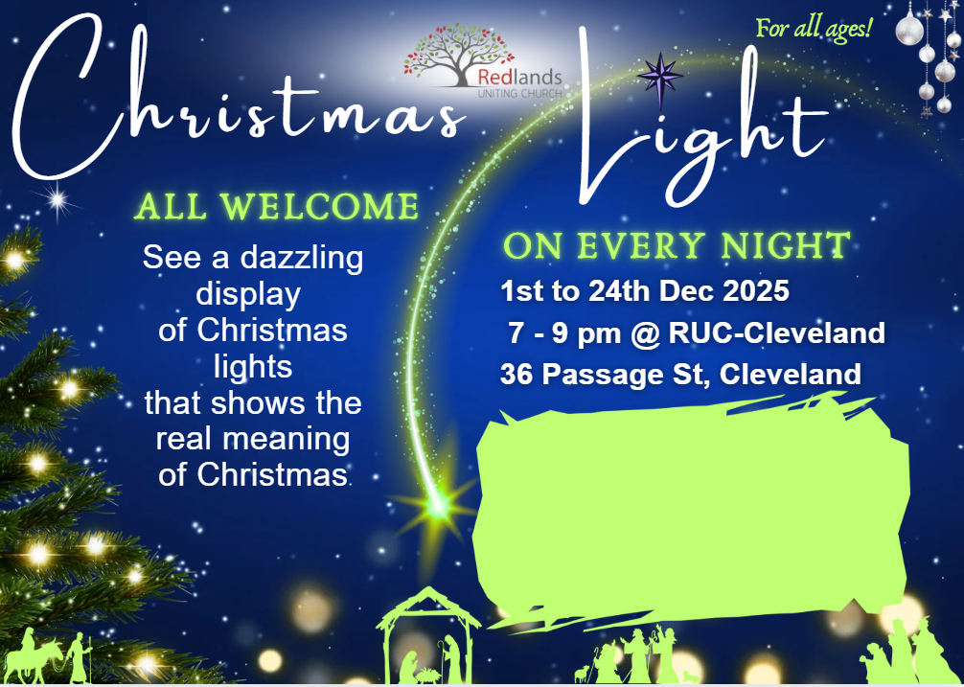
Featuring:
Redland City Band
17th December from 7.00pm

